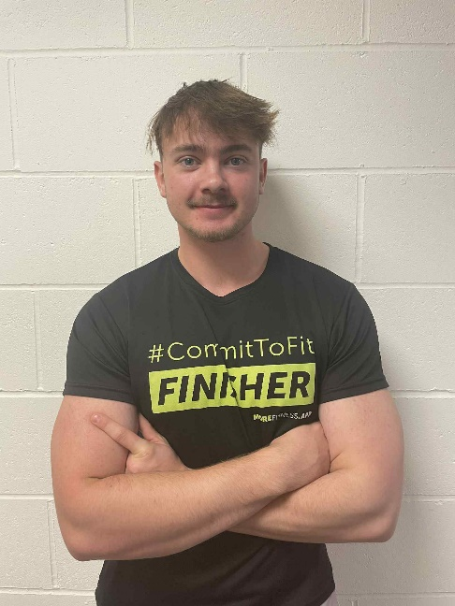

**Academic:**

* WNC

**Gym Instructor**

Level 2

**My specialties**

* General exercise-based training experience
* Traditional Weight training
* Free weight exercises
* Muscle building
* Losing body fat



I’m regulated by:

The Chartered Institute for the Management of Sport and Physical Activity (CIMSPA) Member number 35366

**My Qualifications**

**Personal Trainer** Level 3(Practitioner)

**About me**

**Hello, I’m Jake and I’m a certified Personal Trainer with a passion for weight training and exercise.**

**I can support achieving the following goals:**

* Increasing muscle mass and strength
* Losing body fat
* Increasing fitness levels
* Improving quality of life through selection of exercise

I will make you a custom, tailored training program based on your goal and help improve your health, muscle and strength levels

I will also give you dietary advice based on your goals and what I believe will work the best, as well as making small changes to bad habits, exercise technique and programming your week based on your work life.

PERSONAL TRAINER PROFILE

Jake Walker

**How do you book me?**

Call: **07719356837** Email: **jakeleonwalker@gmail.com**

or ask at reception for my details.